Exp.No:5DeterminationandplottingofElectricpotentialdifferencebetweenany two points in free space medium separated by a distance R.

Date:
Aim:
TowriteprogramforElectricpotentialdifferencebetweentwopointsinfreespace mediumusing SCILAB.

Softwarerequired:
- SCILAB version6.0.1

Theory:
Program:
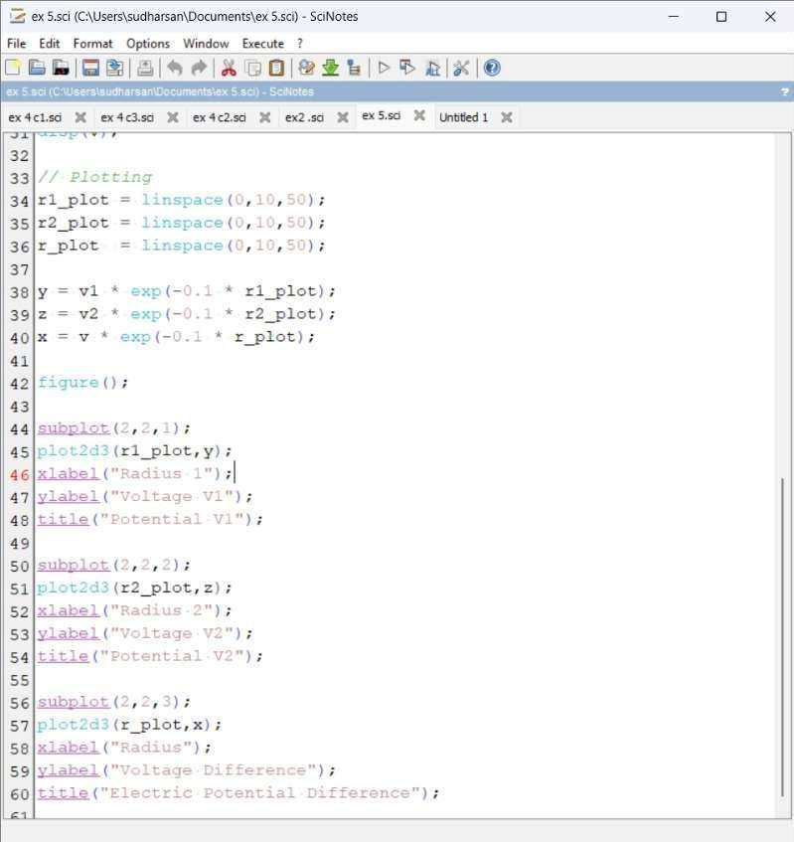
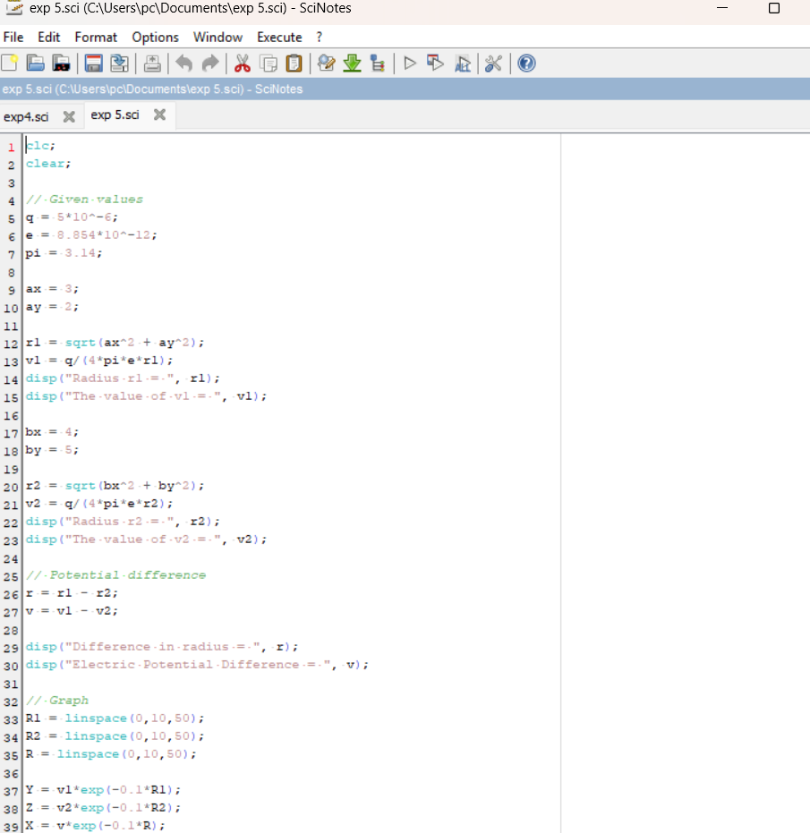
Output:
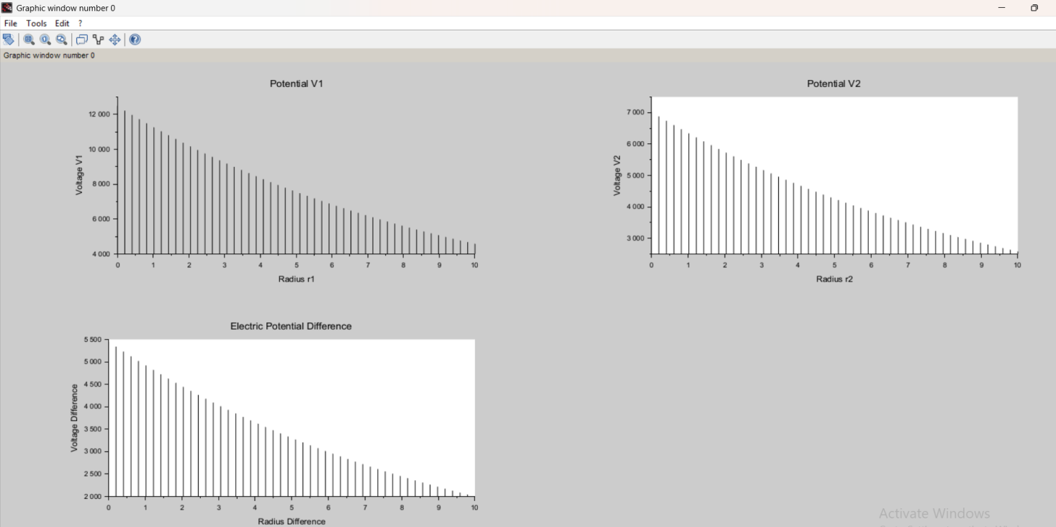

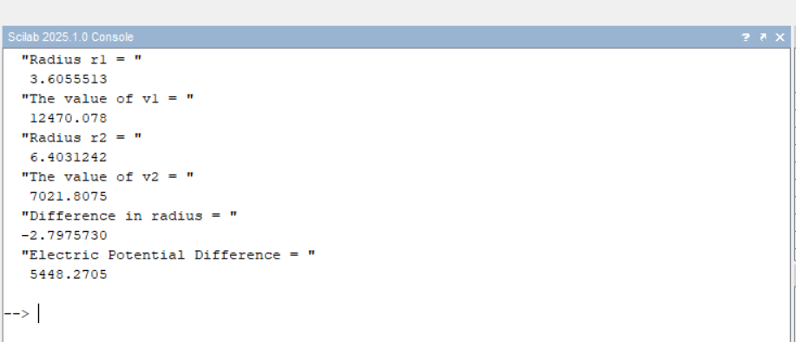

Calcution:

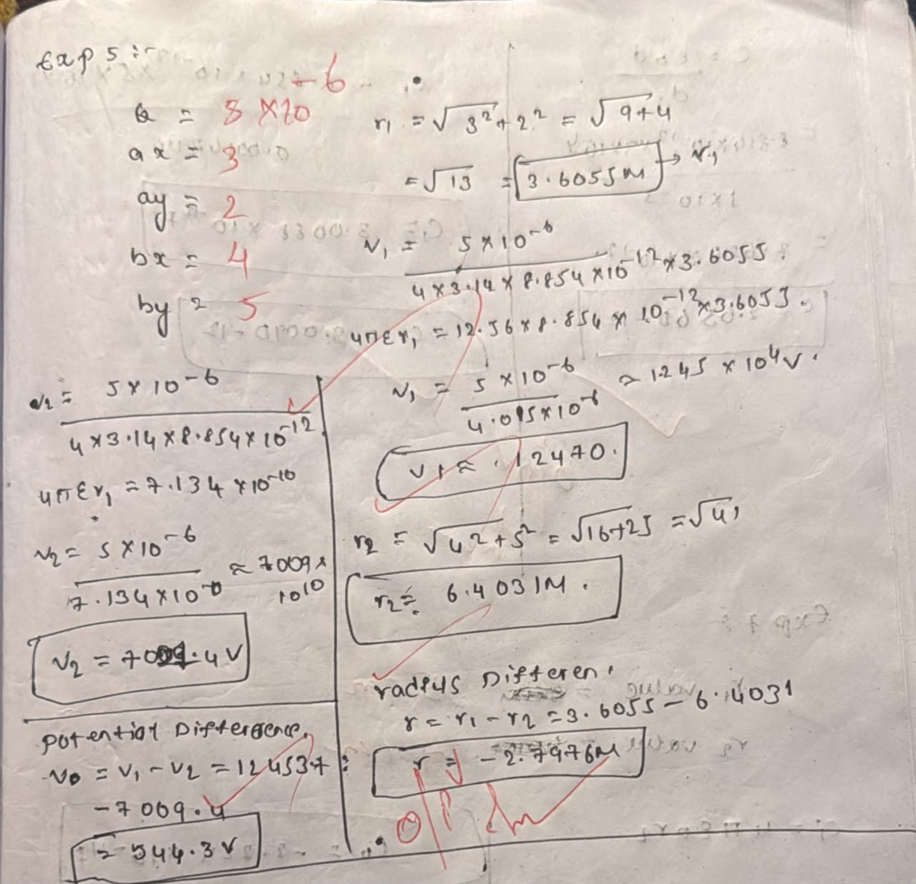

Case1:Apositivechargewithfixedr1=1mr2varying.

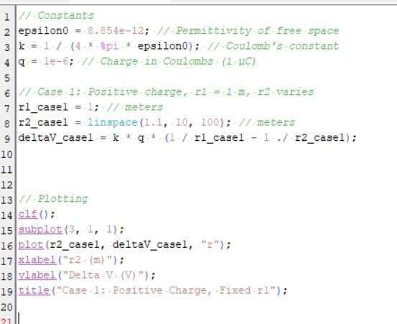

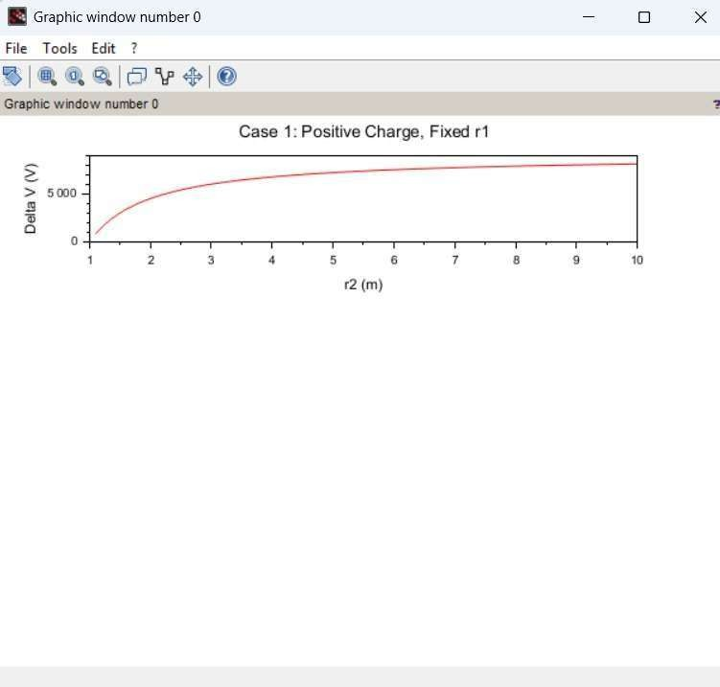
Output:

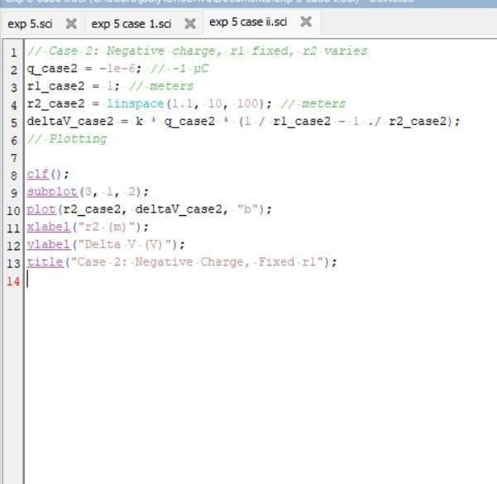

Output:
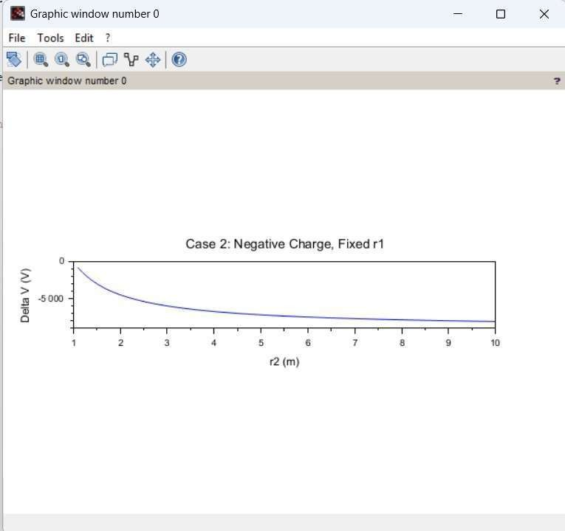

Case3:Bothpointsr1r_1r1andr2r_2r2varywithapositivecharge.

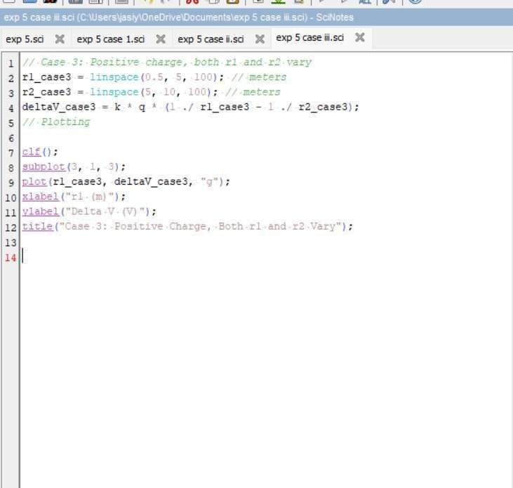

Output:
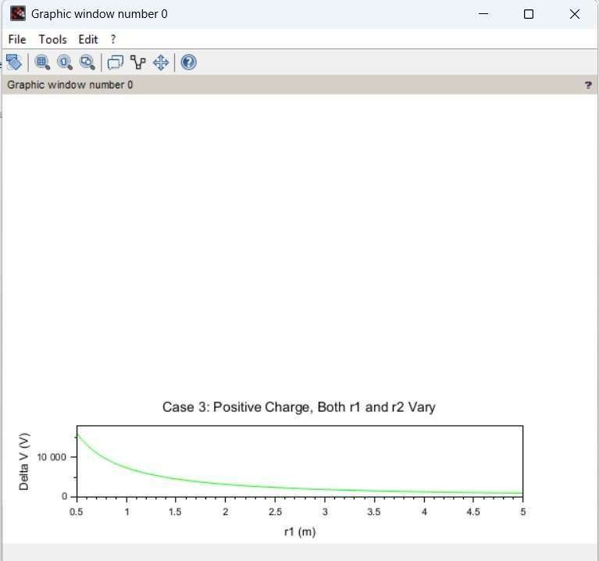

Result:
ThustheprogramwasverifiedforElectricpotentialdifferencebetweentwopointsin free space medium using SCILAB was successfully.

